Name Bilal Abid Abbasi

Class 1 semester

Pf lab assignment

Iqra University
Islamabad Campus Fall Semester 2026

LAB TASK 10
Course Code: CSC 131 | Course Title: Programming Fundamental
Teacher’s Name: Mr. Ilyas Badshah | Total Marks: 10
Deadline: 10 Jan 2026 | Time: 11 59 pm

1. Function add – sum of two integers
#include <iostream>
using namespace std;

int add(int a, int b) {
return a + b;
}

int main() {
int x = 5, y = 7;
cout << "Sum = " << add(x, y);
return 0;
}
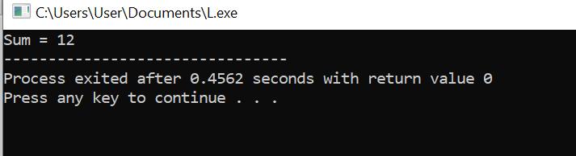

Output
Sum = 12

2. Function factorial – factorial of a number
#include <iostream>
using namespace std;

int factorial(int n) {
int fact = 1;
for (int i = 1; i <= n; i++) {
fact *= i;
}
return fact;
}

int main () {
int num = 5;
cout << "Factorial of " << num << " = " << factorial(num);
return 0;
}
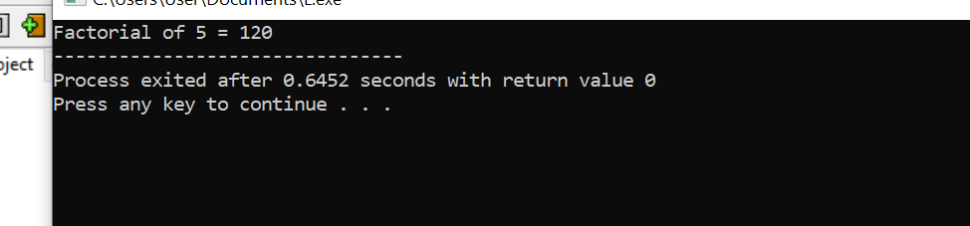

Output
Factorial of 5 = 120

3. Function isPalindrome – check palindrome string
#include <iostream>
using namespace std;

bool isPalindrome(string str) {
int start = 0, end = str.length() - 1;
while (start < end) {
if (str[start] != str[end])
return false;
start++;
end--;
}
return true;
}

int main() {
string word = "level";
if (isPalindrome(word))
cout << word << " is a palindrome";
else
cout << word << " is not a palindrome";
return 0;
}
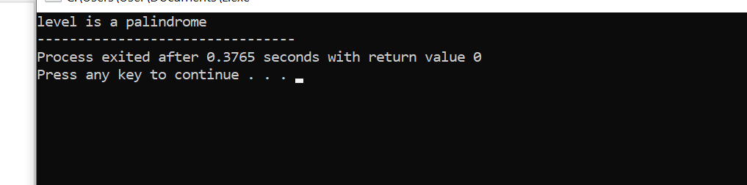

Output
level is a palindrome

4. Function power – base raised to exponent
#include <iostream>
using namespace std;

int power(int base, int exp) {
int result = 1;
for (int i = 1; i <= exp; i++) {
result *= base;
}
return result;
}

int main() {
int b = 2, e = 3;
cout << b << " raised to " << e << " = " << power(b, e);
return 0;
}
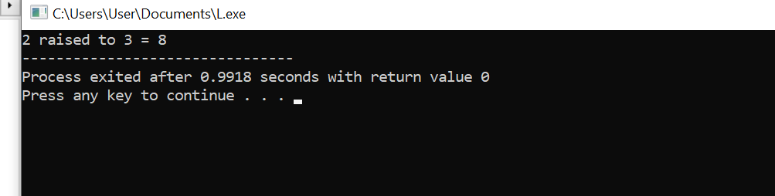

Output
2 raised to 3 = 8

5. Function GCD – greatest common divisor
#include <iostream>
using namespace std;

int GCD(int a, int b) {
while (b != 0) {
int temp = b;
b = a % b;
a = temp;
}
return a;
}

int main() {
int num1 = 24, num2 = 36;
cout << "GCD of " << num1 << " and " << num2 << " = " << GCD(num1, num2);
return 0;
}
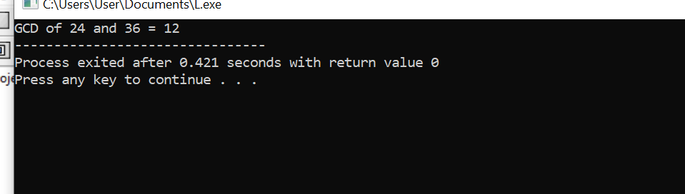

Output
GCD of 24 and 36 = 12

